Self-Regulatory Processes

“[We can] view the structure of self-regulatory processes in terms of three cyclical phases. The forethought phase refers to processes and beliefs that occur before efforts to learn; the performance phase refers to processes that occur during behavioral implementation, and self-reflection refers to processes that occur after each learning effort.”

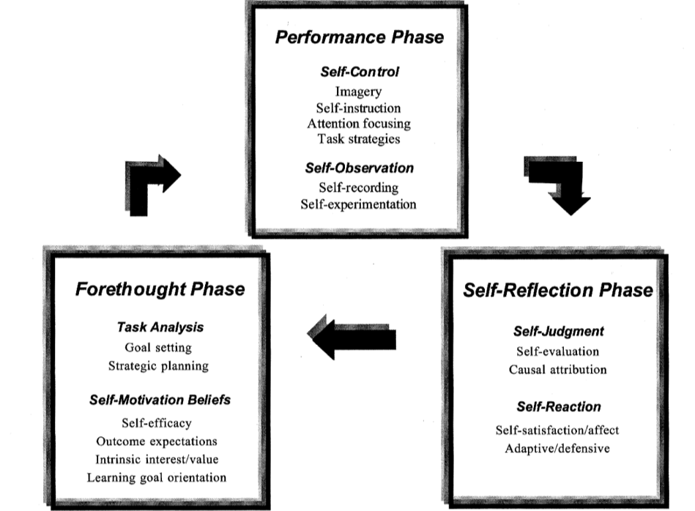

- From B. Zimmerman, “Becoming a Self-Regulated Learner: An Overview.” Theory Into Practice 41(2):64-70, June 2002. DOI: 10.1207/s15430421tip4102_2

